IEEE INTERNET OF THINGS JOURNAL, VOL. 1, NO. 4, AUGUST 2014

349

A Vision of IoT: Applications, Challenges, and Opportunities With China Perspective

Shanzhi Chen, *Senior Member, IEEE*, Hui Xu, Dake Liu, *Senior Member, IEEE*, Bo Hu, and Hucheng Wang

***Abstract*—Internet of Things (IoT), which will create a huge network of billions or trillions of “Things” communicating with one another, are facing many technical and application challenges. This paper introduces the status of IoT development in China, including policies, R&D plans, applications, and standardization. With China’s perspective, this paper depicts such challenges on technologies, applications, and standardization, and also proposes an open and general IoT architecture consisting of three platforms to meet the architecture challenge. Finally, this paper discusses the opportunity and prospect of IoT.**

***Index Terms*—Internet of Things (IoT), IoT application, IoT architecture, IoT challenge, IoT standardization.**

I. INTRODUCTION

**T** HE INTERNET of Things (IoT) is regarded as a technology and economic wave in the global information

industry after the Internet. The IoT is an intelligent network which connects all things to the Internet for the purpose of exchanging information and communicating through the information sensing devices in accordance with agreed protocols. It achieves the goal of intelligent identifying, locating, tracking, monitoring, and managing things [1]. It is an extension and expansion of Internet-based network, which expands the communication from human and human to human and things or things and things. In the IoT paradigm, many objects surrounding us will be connected into networks in one form or another. RF identification (RFID), sensor technology, and other smart technologies will be embedded into a variety of applications.

Manuscript received October 30, 2013; revised March 31, 2014 and May 15, 2014; accepted June 29, 2014. Date of publication July 09, 2014; date of current version August 07, 2014. This work was supported in part by the Major National Science and Technology Special Project under Grant 2013ZX03001025-001 and by the National High-Technology Program (863) of China under Grant 2011AA01A101.

S. Chen and H. Wang are with the State Key Laboratory of Wireless Mobile Communications, China Academy of Telecommunications Technology (CATT), Beijing 100191, China, and also with the State Key Laboratory of Networking and Switching Technology, Beijing University of Posts and Telecommunications, Beijing 100876, China (e-mail: chensz@datanggroup.cn; wanghucheng@catt.cn).

H. Xu is with the State Key Laboratory of Wireless Mobile Communications, China Academy of Telecommunications Technology (CATT), Beijing 100191, China, and also with the Datang Telecom Technology & Industry Group, Beijing, China (e-mail: xuhui@catt.cn).

D. Liu is with the Application Specific Instruction-Set Processor (ASIP) Laboratory, Beijing Institute of Technology (BIT), Beijing 100081, China (e-mail: dake@bit.edu.cn).

B. Hu is with the State Key Laboratory of Networking and Switching Technology, Beijing University of Posts and Telecommunications, Beijing 100876, China (e-mail: hubo@bupt.edu.cn).

Digital Object Identifier 10.1109/JIOT.2014.2337336

As a burgeoning thing, there is not a common accepted definition on IoT. Specialists from different perspectives and organizations describe IoT on diverse preference. Typical definitions of IoT from different organizations are shown in Table I.

Following technology evolutions, more and more computing power, storage, and battery capacities become available at relatively low cost and low size. This trend is enabling the development of extreme small-scale electronic devices with identification/communication/computing capabilities, which could be embedded in other devices, systems, and facilities [1]. IoT should have the following three characteristics [6].

1) *Comprehensive Perception*: Using RFID, sensors, and two-dimensional barcode to obtain the object information at anytime and anywhere, it will be a new opportunity. Using it, information and communication systems can be invisibly embedded in the environment around us. Sensor network will enable people to interact with the real world remotely. Identification technologies mentioned here include objects and location identifications. Identification and recognition of the physical world is the foundation of implementing overall perception.

2) *Reliable Transmission*: Through a variety of available radio networks, telecommunication networks, and Internet, objects information can be available in any time. Communication technology here includes a variety of wired and wireless transmission technologies, switching technologies, networking technologies, and gateway technologies. IoT further creates the interaction among the physical world, the virtual world, the digital world, and the society. Machine to machine (M2M), furthermore, is the key implementation technology of the Network of Things, which represents the connections and communications between M2M and Human to Machine including Mobile to Machine.

3) *Intelligent Processing*: By collecting IoT data into databases, various intelligent computing technologies including cloud computing will be able to support IoT data applications. The network service providers can process tens of millions or even billion pieces of messages instantly through cloud computing. Cloud computing technology will thus be the promoter of IoT.

Currently, in China, there are at least 9 billion interconnected devices, and it is expected to reach 24 billion devices by 2020. According to the GSMA, this amount to $1.3 trillion

2327-4662 *?*c 2014 IEEE. Translations and content mining are permitted for academic research only. Personal use is also permitted, but republication/ redistribution requires IEEE permission. See http://www.ieee.org/publications standards/publications/rights/index.html for more information.

350

TABLE I

DEFINITIONS OF THE IOT FROM DIFFERENT ORGANIZATIONS

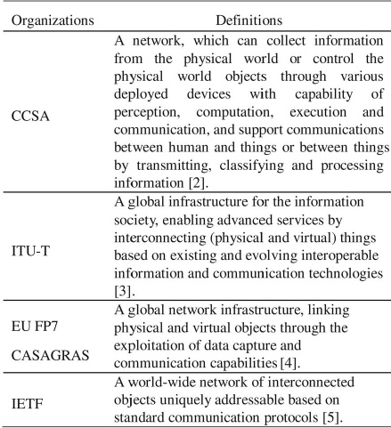

revenue opportunities for mobile network operators alone spanning segments such as health, automotive, utilities, and consumer electronics. Many countries consider IoT as strategic industries and a new economic growth engine in the future. European Union (EU) has invested more than 100 million Euros in a series of projects through Seventh EU Framework Programme (FP7 for R&D), and these projects will be actively deployed in smart grid, intelligent transportation, smart cities, etc. South Korea invested 27.8 million U.S. dollars in IoT fundamental technology development, IoT test bed advancement, and IoT standardization, etc.

China is speeding up the development of IoT and defines it as a new engine for economic growth. The government released the 12th Five-Year Plan for IoT development. This plan is an outline program for developing IoT from 2011 to 2015. The plan gave the goal and objectives of future development, and the plan proposed several approaches reaching the goal. The plan also puts forward a list of methods to support and promote the development of IoT industry.

This paper is organized as follows. Section II introduces opportunities of IoT and summarizes its status and applications. Section III introduces the policy, R&D plans, and standardization of IoT in China. Based on the introduction of Sections II and III, in Section IV, the major problem hampering the development of IoT is analyzed, i.e., lack of interoperability among diverse IoT solutions. A general open IoT architecture developed in China is given. Section V introduces main application fields, examples of typical public applications, and examples of industry applications of IoT in China. Section VI analyzes further challenges on IoT, including technical challenge and standard challenge, and introduces the prospect of IoT. Section VII is the conclusion of this paper.

IEEE INTERNET OF THINGS JOURNAL, VOL. 1, NO. 4, AUGUST 2014

II. OPPORTUNITY, STATUS, AND CAPABILITY OF IOT

*A. Opportunity of IoT*

The IoT will create a huge network of billions or trillions of “Things” communicating each other. The IoT is not subversive revolution over the existing technologies, it is comprehensive utilizations of existing technologies, and it is the creation of the new communication modes. The IoT blends the virtual world and the physical world by bringing different concepts and technical components together: pervasive networks, miniaturization of devices, mobile communication, and new ecosystem. In IoT, applications, services, middleware components, networks, and end nodes will be structurally organized and used in entire new ways.

IoT offers a means to look into complex processes and relationships. The IoT implies a symbiotic interaction between the real/physical and the digital/virtual worlds: physical entities have digital counterparts and virtual representation; things become context aware and they can sense, communicate, interact, and exchange data, information, and knowledge. New opportunities will meet business requirements, and new services will be created based on real-time physical world data.

Everything from the physical or virtual world will possibly be connected by the IoT. Connectivity between the things shall be available to all with low cost and may not be owned by private entities. For IoT, intelligent learning, fast deployment, best information understanding and interpreting, against fraud and malicious attack, and privacy protection are essential requirements.

*B. Status of IoT*

The IoT can be regarded as an extension of existing interaction between people and applications through a new dimension of “Things” for communication and integration.

The IoT development process is a complex large-scale technological innovation process. The IoT is evolving from the vertical application to polymeric application.

At the early stage of IoT deployment, driving of domain-specific applications is the main development strategy. A domain-specific application might be a manufacturing control system with its own industry characteristics. The application can provide various enterprise management services being integrated with the industry production and business processes.

Polymeric applications are cross-industry applications based on public information service platforms. These applications support both home users and industry users. The application are provided and promoted by communication operators and solution providers with large scale. For example, a vehicle integrated with sensor networks, a global positioning system (GPS), and radio communication technology can provide comprehensive detection, navigation, entertainment, and other information services. By maintaining such information through the public service platform, consumers, original equipment manufacturers (OEMs), maintenance providers, and vehicle management agencies can share these information and share services to improve the vehicle, the vehicle component design, and the fabrication process through the vehicle lifecycle management.

CHEN *et al*.: VISION OF IoT: APPLICATIONS, CHALLENGES, AND OPPORTUNITIES WITH CHINA PERSPECTIVE

351

*C. Capability of the IoT Application*

In summary, the IoT applications shall have the following capabilities.

*1) Location Sensing and Sharing of Location Info:* The IoT system can collect the location information of IoT terminals and end nodes, and then provide services based on the collected location information. The location information includes geographical position information got from the GPS, Cell- ID, RFID, etc., and absolute or relative position information between things. More typical IoT applications include at least the following.

a) Mobile asset tracking: This application can track and monitor the status of commodity using the position- sensing device and communication function installed on the commodity.

b) Fleet management: The manger of the fleet can schedule the vehicles and drivers based on the business requirements and the real-time position information collected by the vehicles.

c) Traffic information system: This application can get traffic information such as road traffic conditions and congested locations by tracking the location information of a large number of vehicles. The system thus assists the driver to choose the most efficient route.

*2) Environment Sensing:* The IoT system can collect and process all kinds of physical or chemical environmental parameters via the locally or widely deployed terminals. Typical environmental information includes temperature, humidity, noise, visibility, light intensity, spectrum, radiation, pollution (CO, CO2, etc.), images, and body indicators. Typical applications include at least the following.

a) Environment detection: IoT systems offer environmental and ecological, such as forest and glacier, monitoring; disaster, such as volcanoes and seismic, monitoring; and factory monitoring. All are with automatic alarm systems using environmental parameters collected by large number of sensors.

b) Remote medical monitoring: IoT can analyze the recurring indicator data collected from the device placed on patients’ body and provide the users with health trends and health advice.

*3) Remote Controlling:* IoT systems can control IoT terminals and execute functions based on application commands combined with information collected from things and service requirements.

a) Appliance control: People can remotely control operat-

ing status of appliances through IoT system. b) Disaster recovery: Users can remotely start disasters treatment facilities to minimize losses caused by disasters according to the monitoring mentioned before.

*4) Ad Hoc Networking:* IoT system shall have rapidly self-organized networking capability and can interoperate with the network/service layer to provide related services [7]. In the vehicle network, in order to transfer the data, the network between vehicles and/or road infrastructures can be rapidly self-organized.

*5) Secure Communication:* IoT system can further establish secure data transmission channel between the application

TABLE II SUMMARY OF IOT APPLICATIONS

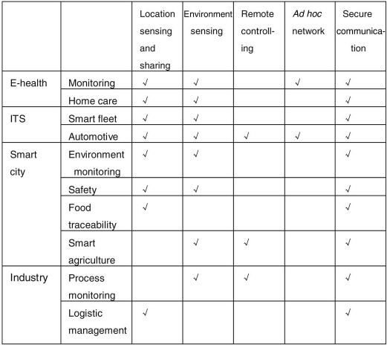

or service platform and IoT terminals based on service requirements.

In practice, an IoT application consists of different types of capabilities and even applications based on the service requirement. Table II shows examples of different IoT applications.

III. IOT IN CHINA

*A. China Pushes Development of IoT*

The IoT sensing network research started in China in 1999. IoT was positioned as one of the strategic emerging industries and written into the government work report in March 2010. The state council’s decision on speeding up the incubation and development of strategic emerging industries, which was promulgated in November 2010, clearly stated that the IoT research and application demonstrations will be promoted.

In 2012, the Ministry of Industry and Information of China explained the national 12th Five-Year Plan including IoT development (2011–2015) [8]. It was the first plan that China government released the development of IoT in detail. The plan clearly proposed the development goal of the IoT during the period of 2011–2015. By 2015, there should be significant achievements of IoT essential technologies, related applications, and standardizations.

The plan put forward eight main tasks and clearly clarified five key projects, including the Key Technology Innovation Project, Standardization acceleration Project, “10 Industrial sectors & 100 New Enterprises” Industry Development Pioneering Project, Application Demonstration Projects in Key Sectors, and Public Service Platform Construction Project.

In order to solve the popped-up problems and consider long-term development of IoT, the State Council issued the “guidance on tracking and ordering for promoting the development of IoT” [9] that determined the development goals and threads for IoT in February 2013. The 14 ministries of

352

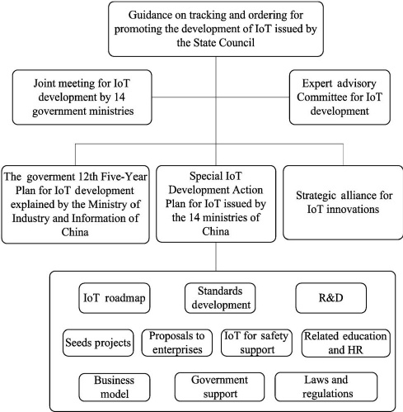

Fig. 1. Summary of the Special Action Plans.

China established a joint meeting for IoT development in September 2013, and organized Expert Advisory Committee on the IoT development. The 10 Special Development Action Plans for IoT [10], including: 1) top-layer design; 2) standards development; 3) technology development; 4) application promotion; 5) industry support; 6) business models; 7) security; 8) government support; 9) laws and regulations guarantee; and 10) personnel training, was issued by the joint meeting. As a part of the Action Plans, the strategic alliance for industrial technology innovations of IoT was established in October 2013 [11]. Fig. 1 shows the summary of the Special Development Packet Plans.

*B. R&D Plans*

In China, the central government established the special funds for demonstration projects and research projects to support the development of IoT. In 2011, for supporting the development of IoT in China, around RMB 500 million special IoT fund was invested into IoT-related fields, 2/3 of the funds were put into R&D and applications; this fund has supported 381 related companies since 2011. China government has supported 22 National major IoT application demonstration projects since 2011, and an announcement was issued by China National Development and Reform Commission in October 2013. It was about organizing and carrying out the national IoT pilot major application demonstration projects during 2014– 2016 in special regions.

In Research and Development area, the China Ministry of Industry and Information Technology had set up a number of key technical research projects on architectures and applications such as intelligent transport system (ITS) and e-health under the packet of “a new generation of mobile broadband project.” China Ministry of Science and Technology also set up a series of fundamental researches for IoT on

IEEE INTERNET OF THINGS JOURNAL, VOL. 1, NO. 4, AUGUST 2014

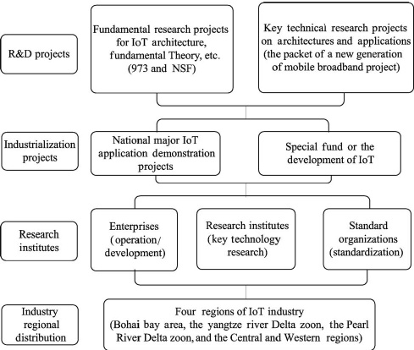

Fig. 2. Summary of National R&D plans in IoT in China.

architecture, fundamental theory and design, etc., under the 973 project framework (National Key Fundamental Research and Development Plan).

The national level IoT R&D is distributed as: the enterprises such as operators and vendors provide the operation and system development of IoT. Universities and research institutions focus on the key technology research, and the standard organizations are responsible for the standardization of IoT. At present, IoT-related industry has basically formed, and mainly distributed over the Bohai bay area, the Yangtze River Delta zoon, the Pearl River Delta zoon, and the central and western regions. Fig. 2 shows the summary of national R&D plans in IoT.

*C. Standardization*

The IoT standard system contains the architecture standards, the application requirements standards, the communication protocol standards, the identification standards, the security standards, the application standards, the data standards, the information processing standards, and the public service platform standards.

The proposed IoT standard set is relatively complicated. In China, the standardization efforts started at 2010. The main standard organizations for IoT in China are China Communications Standards Association (CCSA), China Standardization Working Group on Sensor Networks (WGSN), electric tag standards technical committee, etc. These standard organizations are leading the standardization process of China IoT. As part of the Special IoT Action Plans, actions for the standardization of IoT include to build a standard system, to develop common standards, key technical standards, and urgent industry standards, to actively participate in the international standardization processes, to conduct standard validations and services, to improve the organizational structure.

In the course of standardization, many research institutions and enterprises in China have also been participating in international standardization work in M2M of International Organization for Standardization/International Electrotechnical

CHEN *et al*.: VISION OF IoT: APPLICATIONS, CHALLENGES, AND OPPORTUNITIES WITH CHINA PERSPECTIVE

353

Commission (ISO/IEC), ITU Telecommunication Standardization Sector (ITU-T), 3rd Generation Partnership Project (3GPP). China is one of the leading countries in ITU-T and ISO Wireless Sensor Network (WSN) Working Group. CCSA is one of the sponsoring organizations of the One M2M, and many enterprises are deeply participating in the MTC-related standard development in 3GPP.

IV. OPEN AND GENERAL IOT ARCHITECTURE

*A. Motivation and General Description*

As seen in the previous introduction to the current IoT, most IoT applications in China were domain-specific or application-specific solutions. The architectures of these IoT systems are fragmented and cannot correlate and integrate the data from different silos; these isolated IoT solutions use private protocols and cause much problems in information sharing, technology multiplexing, network managements, and upgrading. All these problems are hindering the development of IoT.

In order to reduce the total IoT cost and share information, we need to integrate multiple functions and resources into a larger system. IoT thus needs to be designed with an open and generic IoT architecture with open interfaces and resources, considering different business scenarios, application-based requirements, and current technologies [12]. We have thus seen the motivation to formulate a standard for IoT integration in order to reduce the total cost of money and time from devices, developments, and deployments.

An open and generic IoT architecture is an integrated solution with interoperability [13], [14]. It will have the following characteristics.

*1) Standard Interface and Protocol:* By comparing various private IoT systems, a generic IoT infrastructure has the same hardware and software interfaces, and protocols.

*2) Public and Operating:* A general IoT architecture is deployed to take over public IoT applications with open- operating capability. A public IoT system can thus integrate multiple IoT applications into one architecture.

*3) Open, Scalable, and Flexible:* An open IoT architecture with open resources, open standards, and open interfaces can easily extend its functionality and the scale of performance. It can thus adapt to different requirements including technical developments flexibly.

*B. Open and General IoT Architecture*

China Communications Standards Association (CCSA) proposed a reference model for the IoT, which consists of sensing layer, network and business layers, and application layer. Complying with this reference model, Fig. 3 shows its open and general architecture, which is layered, open, and flexible. The architecture includes three functional platforms as follows.

*1) Sensing and Gateway Platform:* This platform connects sensors, controllers, RFID readers, and location sensing device (e.g., GPS) to IoT network layer. Modularization of hardware, data format, and software interface is proposed for IoT terminal, IoT Gateway, and tip node. IoT terminal, IoT gateway, and tip node can include flexible modules combined with control

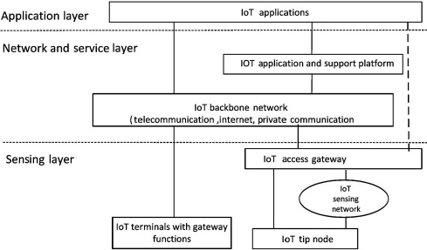

Fig. 3. CCSA proposed open and general architecture of IoT.

module, common interface module, and communication module. Common interface module collects physical interfaces of various sensors into a common interface. Common control module can connect sensors, controllers, GPS, and RFID readers with a common connection protocol. The software and application parameters of an IoT terminal and IoT gateway should be able to self-configure and self-adapt. Modularization, common interface, intelligent operation, self-adaption, and self-configuration are important characteristics of this platform.

*2) Resource and Administration Platform:* Network and service layer includes backbone networks and resource administration platforms. The backbone network includes 3G, 4G, internet, optical fiber network, Ethernet network, satellite networks, and private network. The resource and administration platform provides common capabilities which can be used by different IoT applications, such as data processing, data storage, security management, and application supporting. These capabilities may also be invoked by specific IoT application support capabilities, e.g., to build other specific IoT application support capabilities. This platform also provides relevant control functions of network connectivity, such as access and transport resource control functions, mobility management, or authentication, authorization, and accounting for IoT terminals, services, applications, users, and developers.

*3) Open Application Platform:* Modularization design in this application platform provides common function and open application programming interface (API). An IoT application provider can develop its application using these APIs. Meanwhile, this platform supports application managements. Various applications can be published to the application platform and users can get application information and subscribe applications through this platform. Convenient and easy deployment, distribution, and flexible application environment are the characteristics of this platform.

V. TYPICAL APPLICATIONS AND DEPLOYMENT IN CHINA

*A. Main Application Fields*

In China, IoT applications will be developed in nine fields, including: 1) domain industry applications; 2) smart agriculture; 3) smart logistics; 4) intelligent transportation; 5) smart grid; 6) smart environmental protection; 7) smart safety; 8) smart medical care; and 9) smart home, as shown in Table III.

354

TABLE III

MAIN APPLICATION FIELDS IN CHINA

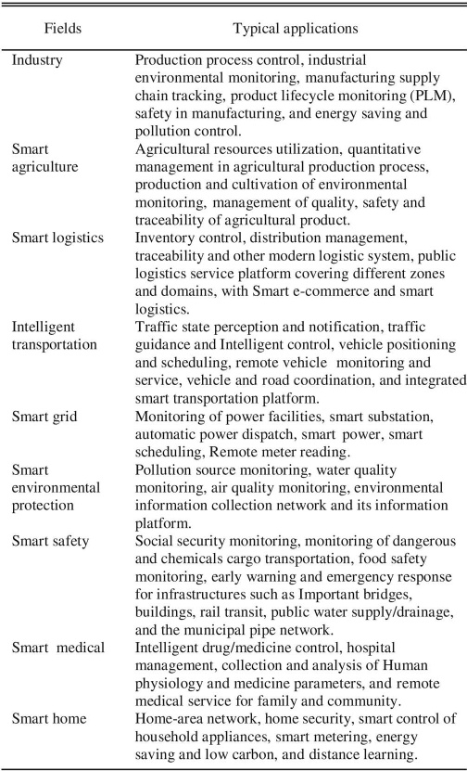

Three major operators: 1) China mobile; 2) China Telecom; and 3) China Unicom had announced their IoT development plans. The IoT has been an important part in the strategies of Chinese telecom operators.

China mobile plans to implement a centralized platform [China mobile IoT operation supporting platform (CMITS)], and the branch for IoT was established in Chongqing in 2012.

China Telecom plans to further enrich IoT services based on key industry requirements, to build an open platform for cooperation, and to promote IoT business model innovation. The branch for IoT was established in Wuxi in 2014.

China Unicom plans to build a management and control platform and an operation supporting system for IoT. They also planned to offer specific hardware communication modules.

The government planned to provide special phone numbers (1064xxxxxxxxx with billions of identities) dedicated for M2M. Table IV shows IoT development plans and actions from three major operators.

IEEE INTERNET OF THINGS JOURNAL, VOL. 1, NO. 4, AUGUST 2014

TABLE IV

IOT DEVELOPMENTS FROM THREE MAJOR OPERATORS

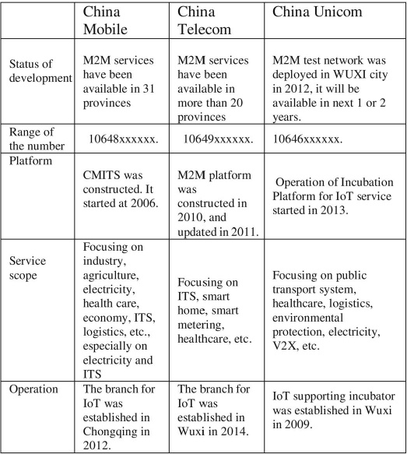

*B. Deployment of Typical Applications*

*1) Smart City:* Smart city is a new development model of a city using new technologies, such as IoT, cloud computing, and big data analytics, to boost the information sharing and coordination within a city system. IoT is important means and tools of building smart city, and it is infrastructure- carrying smart city construction. Smart city construction depends on a lot of IoT applications for different industries [15], [16].

Smart city development plans are divided into three stages: 1) the stage for initial infrastructure construction; 2) the stage for data-processing facility construction; and 3) the stage for end-phase service platform construction. A large number of smart city projects provide huge opportunities for telecom OEM, systems integration enterprises, data aggregation and analysis/service enterprises, and telecom operators. In China, some cities are focusing on improving infrastructure for smart cities programs, and on developing regional smart e-commerce and logistics, while other cities are stepping up efforts to improve the management of local utilities. According to estimation, the smart city market will have a total value of more than RMB 2 Trillion during the 12th Five-Year Plan period (2011–2015).

*2) Intelligent Transportation:* China needs a solution to solve the problems of increased amount of traffic congestion in urban areas using new technologies such as IoT.

The Ministry of Transport in China has announced a plan that the development of ITS will be installed and in-use across the country by 2020. In the next 10 years, the government will invest about RMB 4 Trillion in intelligent transportation.

CHEN *et al*.: VISION OF IoT: APPLICATIONS, CHALLENGES, AND OPPORTUNITIES WITH CHINA PERSPECTIVE

355

Intelligent Transportation System in China is developing and keeping a high growth rate. The growing speed of China’s urban intelligent transportation control system market is high, including electronic police, intelligent traffic signal control, traffic video monitoring, intelligent Taxi service management, urban public transport information technology, and ETC. Until the completion of the 12th Five-Year Plan, 60% of national highways in China will have ETC. The installation of IoT infrastructures in ITS of smart cities will be supporting fundamental technologies.

Connected vehicles and vehicular networks have been identified as a key technology for enhancing road safety and transport efficiency [17], [18]. In recent years, vehicular network infrastructure integration technology attracts a great amount of attentions; it also brings inestimable economic value, and will play an important role in the next generation of intelligent transportation systems and communication network development. Separately, built-in connectivity in vehicles is predicted to mandatory function for consumers in 2020, driven partly by the increasing global demand for availability of charging supply for electric vehicles. Government, University, automakers, and telecommunication vendors form alliances to develop this industry, such as China ITS Industry Alliance and Telematics Industry Application Alliance, to develop the connected vehicles industry. The related installation of IoT infrastructures of smart cities will be fundamental supporting technologies as well.

*C. Deployment of Typical Industry Applications*

*1) Intelligent Coal Mine:* In 2011, The State Administration of work safety and State Coal Mine Safety Supervision Bureau in China regulated that all coal mines in china must complete the construction of “Mine Six-Hedge Safety Systems” until the end of 2013. The Six-Hedge underground systems include: 1) general monitoring and controlling system; 2) personnel positioning system; 3) emergent shelter systems; 4) oxygen provision monitoring system; 5) water supply and drainage monitoring system; and 6) mine cable and wireless communication system.

All the six systems mentioned above are based on pervasive sensing, sensing data collection, real-time use of data, and deep data post analyses, which is actually based on IoT. The IoT can be widely used in the “six system.” For example, it uses sensors to monitor miner position and leak of hazard gases. Fig. 4 shows a typical underground IoT system.

Built on underground industrial ring network and industrial field bus, the system is actually a comprehensive underground IoT platform, which transmits data of mining devices under industrial Ethernet protocols to dispatch center so as to monitor various devices and sensors inside the dispatch center. The overall design of the system consists of sensing and equipment layer, network and access layer, as well application and information management layer. The system collects real-time parameters of electromechanical devices and data of safety systems, which improves the system efficiency and safety. Finally, it highly guarantees the correct dispatching and decision-making of coal mines.

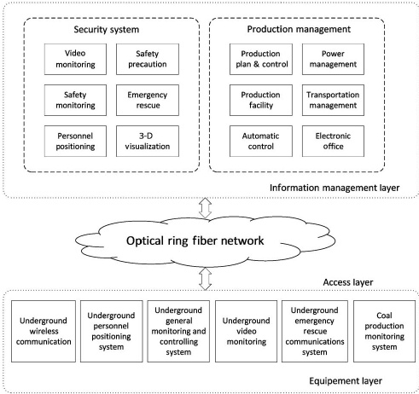

Fig. 4. IoT system structure for coal mine.

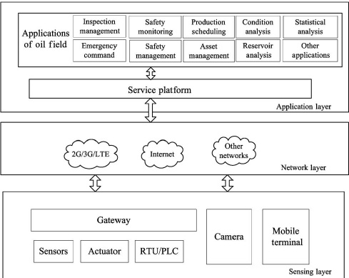

Fig. 5. IOF system.

*2) Intelligent Oil Field:* Intelligent oil field (IOF) consists of a distributed system, holding frequently captured data. The data are evaluated and acted upon real-time information. IOF brings lower operational costs, lower capital investment, and increased yield of oil and gas.

Fig. 5 shows the IOF system based on the architecture mentioned in Section IV. It will collect parameters through its entire production process, such as sensing and monitoring parameters from oil well and gas well, metering house, oil station and gas station, and oil and gas pipe network. Sensed data will be collected and transmitted for further analysis between the service platform and gateway/terminal with a common connection protocol. Real-time production data and equipment condition information support the centralized management and control at production command center in production control center. IOF can increase the integrity, accuracy, timeliness, and standardization of the production decision-making for oil and gas fields.

356

The goal and objectives of the IOF system are to increase the accuracy and timeliness of product process, decision-making, improvement of the system management level, reducing the operation costs, and minimizing risk. As a subsystem in IOF, IoT system offers automatic production data collection, remote monitoring, and supporting for production prewarning by establishing a standardized general service platform, which covers all oil and gas wells and fields, metering house, collect and conveyance station, combination station, treatment plant. The platform also supports the process of production process management.

VI. CHALLENGE AND PROSPECT OF IOT

IoT trends to be unified, seamless, and pervasive. Large-scale service deployment needs to be framed within a set of standards. However, IoT involves many manufacturers, spans multiple industries, and it differs widely in application scenarios and user requirements, which consequently gives impacts on large-scale commercial deployment of related services. The development of IoT is a step-by-step process. There are still many problems to be solved, such as low power nodes and computing, low cost and low latency communication, identification and positioning technologies, self-organized distributed systems technology, and distributed intelligence.

*A. Challenge of IoT*

The IoT provides many new opportunities to the industry and end user in many application fields. Currently, however, the IoT itself lacks theory, technology architecture, and standards that integrate the virtual world and the real physical world in a unified framework [19]. Following key challenges are thus listed.

*1) Architecture Challenge:* IoT encompasses an extreme wide range of technologies. IoT involves an increasing number of smart interconnected devices and sensors (e.g., cameras, biometric, physical, and chemical sensors) that are often nonintrusive, transparent, and invisible. As the communications among these devices are expected to happen anytime, anywhere for any related services, generally, these communications are in a wireless, autonomic, and *ad hoc* manner. In addition, the services become much more mobile, decentralized, and complex. In IoT, data integrations over different environments are thus tough and will be supported by modular interoperable components. Infrastructure solutions will require systems to combine volumes of data from various sources and determine relevant features, to interpret data and show their relationships, to compare data to historical useful information, and support decision-making. Single reference architecture thus cannot be a blueprint for all applications. Heterogeneous reference architectures have to coexist in IoT. Architectures should be open, and following standards, they should not restrict users to use fixed, end-to-end solutions. IoT architectures should be flexible to cater for cases such as identification (RFID, tags), intelligent devices, and smart objects (hardware and software solutions).

*2) Technical Challenge:* IoT technology can be complex for variety of reasons. First, there are legacy heterogeneous

IEEE INTERNET OF THINGS JOURNAL, VOL. 1, NO. 4, AUGUST 2014

architectures in the existing networking technologies and applications, e.g., different applications and environments need different networking technologies, and the ranges as well as other characteristics of cellular, wireless local area network, and RFID technologies are much different from each other [20]. Second, communication technologies, including fixed and mobile communication systems, power line communications, wireless communication, and short-range wireless communication technologies, for both fixed and mobile devices, either simple or complicated, should be low cost and with reliable connectivity. At last, there are thousands of different applications; it is in natural to have different requirements on what parties need to communicate with each other, what kind of security solutions are appropriate, and so on.

To summarize, complexity and alternative technologies may introduce problems; unnecessary competition and deployment barriers in markets may also introduce problems; systems and communication mechanisms with unnecessary dependencies may block the migration of IoT systems to the most economic and efficient platforms. All the above may block IoT to connect as many “Things” as possible.

*3) Hardware Challenge:* Smart devices with enhanced inter-device communication will lead to smart systems with high degrees of intelligence. Its autonomy enables rapid deployment of IoT applications and creation of new services. Therefore, hardware researches are focusing on designing wireless identifiable systems with low size, low cost yet sufficient functionality.

As the bandwidth of IoT terminals could vary from kbps to mbps from sensing simple value to video stream, requirements on hardware are diverging. However, two requirements have been nevertheless the essentials: one is the extremely low power consumption in sleep mode and the other is ultra low cost. Suppose the sleeping time over active time is one million, the leakage power of an IoT terminal shall at least be one million time less than that of active. It is so far impossible when an IoT terminal is sleeping and receiving RF signals. It will be even difficult when using advanced CMOS silicon with relatively more leakage power. Hardware and protocol codesign for sleeping has been thus the first hardware challenge of IoT.

Billions of IoT terminals will be used; the cost of an IoT terminal must be ultra low. However, so far, there is no low cost positioning solution for IoT, especially the positioning precision of a short-range IoT terminal must be high.

Low active power is also a challenge for low-cost terminal [21]. Traditionally, low cost equals to lower performance or longer process latency. Longer processing latency ends up to higher energy consumption. As the spectrum resource is very limited at the lower part in L band, IoT may use higher RF such as the frequency bands higher than 5 GHz. The higher the RF, the more power consumption from RF PA will be.

In another way, not yet used very narrow spectrum band between two used bands may have to be used by future IoT. To use very narrow band with strong power neighbors, the cost of passive component will not be low and that will definitely be a potential challenge in the future.

CHEN *et al*.: VISION OF IoT: APPLICATIONS, CHALLENGES, AND OPPORTUNITIES WITH CHINA PERSPECTIVE

357

*4) Privacy and Security Challenge:* Compared with traditional networks, security and privacy issues of IoT become more prominent [22]. Much information includes privacy of users, so that protection of privacy becomes an important security issues in IoT. Because of the combinations of things, services, and networks, security of IoT needs to cover more management objects and levels than traditional network security. Existing security architecture is designed from the perspective of human communication, may not be suitable and directly applied to IoT system. Using existed security mechanisms will block logical relationship between things in IoT.

IoT needs low-cost- and M2M-oriented technical solutions to guarantee the privacy and the security. In many use cases, the security of a system has been considered as a general feature. Related research shall focus on privacy control. Low cost, low latency, and energy-efficient cryptography algorithms and related flexible hardware will be essential for sensor or device.

*5) Standard Challenge:* Standards play an important role in forming IoT. A standard is essential to allow all actors to equally access and use. Developments and coordination of standards and proposals will promote efficient development of IoT infrastructures and applications, services, and devices. In general, standards developed by cooperated multiparties, and information models and protocols in the standards, shall be open. The standard development process shall also be open to all participants, and the resulting standards shall be publicly and freely available. In today’s network world, global standards are typically more relevant than any local agreements.

*6) Business Challenge:* For a mature application, its business model and application scenario are clear and easy to be mapped into technical requirements. So the developers do not need to spend much time on business-related aspects. But for IoT, there are too many possibilities and uncertainties in business models and application scenarios. It is thus inefficient in terms of business-technology alignment, and one solution will not fit possibilities for all. The IoT is a challenging traditional business model. Although small-scale applications have been profitable in some industries, it is unsustainable when extended to other industries. In the early stage of IoT development, business aspects should be considered to reduce the risk of failure.

*B. Prospect of IoT*

With the development and maturity of distributed intelligent information processing technologies, IoT systems will make intelligent sensing widely available through information sharing and collaboration. The gradual establishment and improvement of the standards system will inevitably bring IoT into our daily life. The IoT creates an opportunity for the web-based services, thus enhancing the commercial and social potential future of IoT [23].

The development of IoT keeps going forward along scale, collaborative, and intelligent. Promoted by technology, standardization, and application experiences, IoT applications will expand the scale in the different industries, and more enterprises will be attracted to come in.

*1) Interoperability:* Information interoperability will take place among different things, different enterprises, different industries, and different regions or countries; application models will change from closed to open and the globalization of IoT application system serving different industries and fields will be constructed. Interoperability is the essential issue for crossing layers of physical, device, communication (protocol and spectrum utility), function and application. These levels traditionally are built with different languages and protocols. Level and domain transparent languages and protocols are, therefore, needed. A holistic approach is required in addressing and solving the interoperability of IoT devices and services at several layers.

*2) Intelligent System:* The IoT will bring seamless business and social networking over fast reliable and secure networks into our society. System intelligence will be important for the development of IoT and the key point will be context awareness and inter-things information exchange. Therefore, increasing and adapting the intelligence at the device level will be a focus of research, such as the integration of sensors and actuators, high efficiency, multistandard and adaptive communication subsystems, and adaptable antennae.

Intelligences can be introduced using micro control unit (MCU) on upper layers. However, physical layer so far has been far behind the required intelligent level, for example, to adapt IoT devices under different radio infrastructures. Four parts in physical layer must be further developed to adapt to and/or to form an intelligent IoT device, which are as follows.

Programmable baseband processor will be used to adapt to different modulation algorithms, different error correction algorithms, different channel bandwidths, and different channel scenarios.

Software-controlled RF will be essential for transceiver to adapt to the local radio frequency requirements.

Fully digital RF PA will be the indispensable device to consume less low power and offer programmability for PA to adapt radio transmission requirements.

Finally, controllable integrated passive components will be an essential glue to connect intelligent semiconductor components into a sensor node with low cost, low size, and low power.

*3) Energy Sustainability:* In the future, energy-efficient and self-sustainable systems will be key enhancing issues to the IoT. The ways to harvest energy from environments must be developed. Efficiency in processing and communication must also be increased through new circuits, new programming paradigms, and the further development of energy-efficient protocols and smart antennae. The development of new, efficient, and compact batteries, fuel cells, as well as new energy generation devices coupling energy transmission methods or energy harvesting will be the key factors for the roll-out of autonomous wireless smart systems.

Charging of global IoT terminals, power consumption of global IoT access points and gateways, as well as the power consumption of IoT data processing in IoT infrastructures will be one of the dominant power consumers in the future world.

Mechanical energy harvest will be sufficient for body network as a part of IoT.

358

Solar or wind energy is a conditional energy sources which may not be reliable. It can be used for battery charging.

VII. CONCLUSION

The IoT encompasses several technologies such as information technology, cognitive sciences, communication technology, and low-power electronics. IoT creates a newer information society and knowledge economy. But the challenges from research, industries, and the government will keep pushing and investing. The development of IoT will depend on technological advances in silicon scaling and energy-efficient devices, in getting the information from heterogeneous sources, in reducing costs, and in improving efficiencies. The development of the IoT exposed many new challenges including the lack of fundamental theory supporting, unclear architecture, and immature standards. To meet these challenges, we give a three-layer architecture including three platforms. The proposed acting standard can hopefully balance desires from different parties, can open the door for future fundamental theory development, and can eventually stimulate/regulate IoT development. Recent years, Chinese government is pushing the development of the IoT. Following the Chinese 12th Five-Year Plan for IoT Development, China has accomplished a number of demonstration application projects such as the smart city and the intelligent transportation system in public IoT applications, intelligent coal mine, and the IOFs in industry applications. The future of IoT will be expected to be unified, seamless, and pervasive. Large-scale service deployment needs to be framed within a set of standards. Thus, the developments of IoT as an intelligent system can be proceeding with interoperability, energy sustainability, privacy, and security. IoT have become an inevitable trend of development of information industry, which bound to bring new changes to our lives.

REFERENCES

[1] J. A. Stankovic, “Research directions for the Internet of Things,” *IEEE Internet Things J.*, vol. 1, no. 1, pp. 3–9, Feb. 2014.

[2] “*Terms of the Ubiquitous Network*,” CCSA Standard YDB 062-2011, Mar. 2011.

[3] “*Overview of IoT*,” ITU-T Standard Y.2060, Jun. 2012.

[4] I. M. Smith *et al.*, “RFID and the inclusive model for the IoT,” CASAGRAS Partnership Rep., West Yorkshire, U.K., Final Rep., 2009, pp. 10–12.

[5] G. M. Lee *et al.*, “*The IoT—Concept and Problem Statement*,” IETF Standard draft-lee-iot-problem-statement-05, Jul. 30, 2012.

[6] T. Liu and D. Lu, “The application and development of IoT,” in *Proc. Int. Symp. Inf. Technol. Med. Educ. (ITME)*, 2012, vol. 2, pp. 991–994.

[7] J. Huang *et al.*, “A novel deployment scheme for green Internet of Things,” *IEEE Internet Things J.*, vol. 1, no. 2, pp. 196–205, Apr. 2014.

[8] Ministry of Industry and Information Technology of China (2012, Feb.). *The National 12th Five-Year Plan Including IoT Development (2011–2015)* [Online]. Available: http://www.gov.cn/zwgk/2012- 02/14/content 2065999.htm

[9] State Council of China (2013, Feb.). *Guidance on Tracking and Ordering for Promoting the Development of IoT* [Online]. Available: http://www.gov.cn/zwgk/2013-02/17/content 2333141.htm

[10] Ministry of Industry and Information Technology of China (2013, Oct.). *Special Development Action Plans for IoT* [Online]. Available: http://www.miit.gov.cn/ n11293472/ n11293832/ n11293907/n11368223/ 15649701.html

[11] Ministry of Science and Technology of China (2013, Sep.). *The Strategic Alliance for Industrial Technology Innovations of IoT* [Online]. Avail- able: http://www.most.gov.cn/kjbgz/201309/ t20130904 109120.htm

IEEE INTERNET OF THINGS JOURNAL, VOL. 1, NO. 4, AUGUST 2014

[12] J. Gubbi *et al.*, “IoT: A vision, architectural elements, and future directions,” *Future Gener. Comput. Syst.*, vol. 29, no. 7, pp. 1645–1660, Sep. 2013.

[13] K. Yang and Z. Zhang, “Summarize on IoT and exploration into technical system framework,” in *Proc. IEEE Symp. Robot. Appl. (ISRA)*, 2012, pp. 653–656.

[14] A. M. Ortiz *et al.*, “The cluster between Internet of Things and social networks: Review and research challenges,” *IEEE Internet Things J.*, vol. 1, no. 3, pp. 206–215, Jun. 2014.

[15] A. Zanella *et al.*, “Internet of Things for smart cities,” *IEEE Internet Things J.*, vol. 1, no. 1, pp. 22–32, Feb. 2014.

[16] P. Vlacheas *et al.*, “Enabling smart cities through a cognitive management framework for the Internet of Things,” *IEEE Commun. Mag.*, vol. 51, no. 6, pp. 102–111, Jun. 2013.

[17] T. Zhang *et al.*, “Defending connected vehicles against malware: Challenges and a solution framework,” *IEEE Internet Things J.*, vol. 1, no. 1, pp. 10–21, Feb. 2014.

[18] J. Yang and Z. Fei, “Broadcasting with prediction and selective forwarding in vehicular networks,” *Int. J. Distrib. Sensor Netw.*, vol. 2013, pp. 1–9, 2013.

[19] R. Kranenburg and A. Bassi, “IoT challenges,” *Commun. Mobile Com- put.*, vol. 1, no. 1, pp. 1–5, 2012.

[20] Y. Chen *et al.*, “Time-reversal wireless paradigm for green Internet of Things: An overview,” *IEEE Internet Things J.*, vol. 1, no. 1, pp. 81–98, Feb. 2014.

[21] S. Lanzisera *et al.*, “Communicating power supplies: Bringing the internet to the ubiquitous energy gateways of electronic devices,” *IEEE Internet Things J.*, vol. 1, no. 2, pp. 153–160, Apr. 2014.

[22] H. Ning *et al.*, “Cyberentity security in the Internet of Things,” *Computer*, vol. 46, no. 4, pp. 46–53, Apr. 2013.

[23] H. Ning and Z. Wang, “Future IoT architecture: Like mankind neural system or social organization framework,” *IEEE Commun. Lett.*, vol. 15, no. 4, pp. 461–463, Apr. 2011.

**Shanzhi Chen** (SM’04) received the Ph.D. degree from Beijing University of Posts and Telecommunications (BUPT), Beijing, China, in 1997.

He joined the Datang Telecom Technology & Industry Group in 1994, and has been serving as CTO since 2008. He was a Member of the Steering Expert Group on Information Technology of the 863 Program of China from 1999 to 2011. He is a Member of the Advisory Committee of Experts on the IoT development of China, the Director of the State Key Laboratory of Wireless Mobile Communication, China Academy of Telecommunication Technology (CATT), Beijing, China, and the Board Member of the Semiconductor Manufacturing International Corporation (SMIC). He has made great contributions to TD-SCDMA 3G industrialization and TD-LTE-advanced 4G standardization. His research interests include wireless mobile communication, IoT, and emergency communication.

Dr. Chen was the recipient the State Science and Technology Progress Award of China in 2001 and 2012.

**Hui Xu** received the Ph.D. degree from Xian Jiaotong University, Xian, China, in 1999.

She is currently the Manager of the Ubiquitous Network Department, Datang Wireless Mobile Innovation Center, Beijing, China. Her research interests include key technologies in Internet of Things (IoT) and machine to machine (M2M) communications.

**Dake Liu** (SM’08) received the Ph.D. degree from Link¨oping University, Link¨oping, Sweden, in 1995.

He is currently the Director and Professor of the Application Specific Instruction-set Processor (ASIP) Laboratory, Beijing Institute of Technology (BIT), Beijing, China, since 2010. He has also been a Professor with the Department of Electrical Engineering, Link¨oping University, since 2001. He is a cofounder and was the Board Director as well the Chief Scientist Officer of Coresonic AB Ltd., Link¨oping, Sweden, from 2005 to 2012. He is a cofounder, and was the Vice President as well the Chief Engineering Officer of FreeHandDSP AB Ltd., Stockholm, Sweden, from 1999 to 2002. He was a Senior Specialist of Low Power Design for Communication IC with Ericsson Microelectronics, Stockholm, Sweden, from 1995 to 1998. His research interests are ASIP for communications, RF CMOS integrated circuits and RF power amplifier for radio communications.

CHEN *et al*.: VISION OF IoT: APPLICATIONS, CHALLENGES, AND OPPORTUNITIES WITH CHINA PERSPECTIVE

359

**Bo Hu** received the Ph.D. degree in communication and information system from Beijing University of Posts and Telecommunications (BUPT), Beijing, China, in 2006.

He is an Associate Professor with the State Key Laboratory of Networking and Switching Technology, BUPT. His research interests include wireless mobile communication and mobile Internet.

**Hucheng Wang** received the M.S. degree from Beijing University of Posts and Telecommunications (BUPT), Beijing, China, in 2008, and is currently working toward the Ph.D. degree in communication and information systems at BUPT.

He is also currently a Senior Standard Engineer with the China Academy of Telecommunication Technology (CATT), Beijing, China. His research interests include architectures, networking, and protocols for cellular and vehicular networks.